{{DATE}}

**{{CLIENT_NAME}}**

**{{ADDRESS}}**

**ATTENTION: {{CONTACT_PERSON}}**

Dear Sir/Madam,  
  
We take special pleasure in submitting our firm quotation for the KYOCERA DIGITAL COPIER TASKalfa MZ4000i as follows:

**BLACK ‘n WHITE COPY & PRINT, COLORED SCAN**

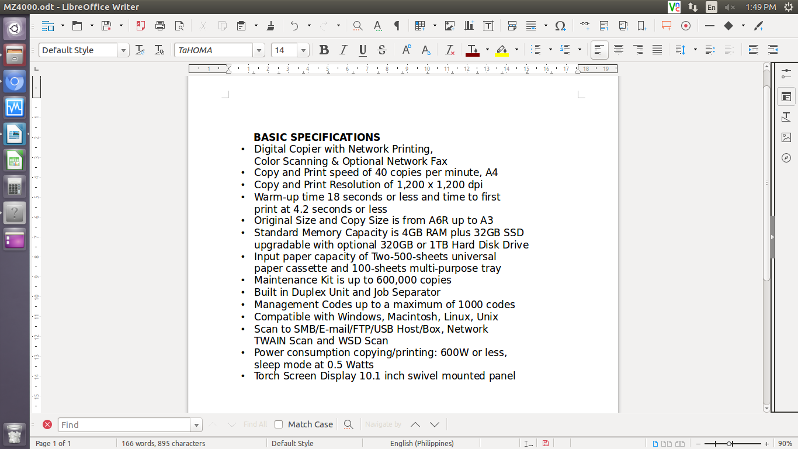

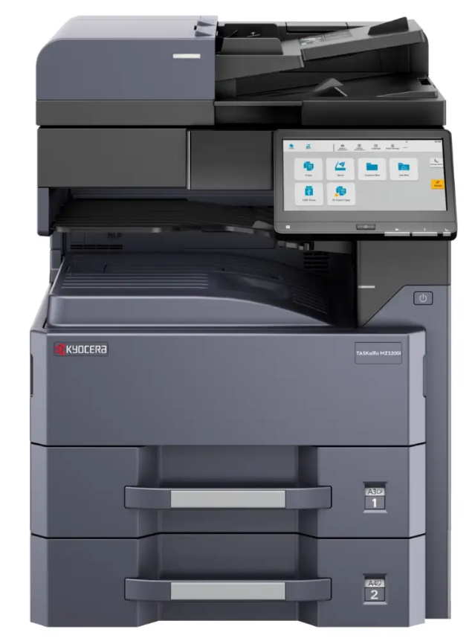

* **PRICE OF MACHINE (VAT INCLUSIVE)**

|  |  |  |
| --- | --- | --- |
| 1 unit of KYOCERA DIGITAL COPIER TASKalfa MZ4000i | Php | **258,000.00** |

**TRADE-IN PROMO**

MACHINE REGULAR PRICE Php 258,000.00

TRADE-IN PROMO DISCOUNT Php 61,200.00

**TOTAL DISCOUNTED AMOUNT Php 196,800.00(less 15% in COD=Php 167,280.00)**

Php 16,400/MO. FOR 12 MONTHS (CREDIT CARD)

**OPTIONAL/ACCESSORIES (NOT INCLUDED IN MACHINE PRICE)**

DOCUMENT PROCESSOR (AUTO-FEEDER) Php 41,900.00

ADDITIONAL PAPER CASSETTE (TWO 500-SHEET) Php 72,000.00

WIFI DIRECT (WIRELESS LAN) Php 13,750.00

STEEL TABLE/CABINET/PEDESTAL Php 6,200.00

5 YEARS ADDITIONAL SERVICE Php 12,750.00

LIFETIME SERVICE WARRANTY Php 14,400.00

* **PRICE OF CONSUMABLES (VAT EXCLUSIVE)**

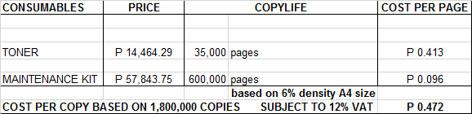

**Terms of Payment:** CASH  
  
**VALIDITY:** Prices are subject to change without prior notice, please confirm with us before finalization of the order.  
  
**WARRANTY:**   
  
KYOCERA DIGITAL PLAIN PAPER COPIERS are guaranteed spare parts replacement FREE OF CHARGE for TWO (2) years, or up to 600,000 copies/print/scan whichever comes first.  
  
Warranty for accessories and options is ONE (1) year from the delivery date.

We also assure you of prompt service whenever you need assistance. Repair service is FREE for TWO (2) years. Should our machine require prolonged service, we shall install a backup unit for your convenience.

Installation and Training of Personnel: Our expert service engineers install all our machines and they will be glad to train interested personnel on the detailed mechanics of the machine free of charge.

We look forward to hearing from you soon. If you have any questions or concerns, please call us at 7618-0274.

Very truly yours, Conforme:

JAYPEE V. SONIEL __________________________________

SENIOR ACCOUNT EXECUTIVE II

09176240820 (Viber Ready)